**Enterprise Resource Planning**

**Training User Manual**

**VERSION 12.0.0**

**Attendance Information**

**Index**

|  |  |
| --- | --- |
| **About** | **Page No.** |
| * File Upload & Process | **03** |
| * Attendance info Update | **04** |
| * Attendance Process | **06** |
| * Roster Entry | **07** |
| * Roster Entry Process | **09** |
| * Roster Update | **10** |
| * Reports | **12** |

# [File Upload & Process](http://192.168.1.17:8090/zab/login?screen=opdoheader&option=Invoice+Entry&menuname=op)

Click the link **Click Here >>** to **Upload Document** in the location folder

**Choose File > Upload** (If file is not correct click **Reset**)

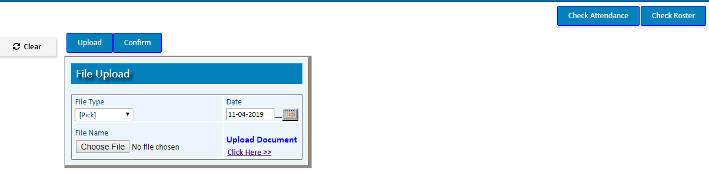

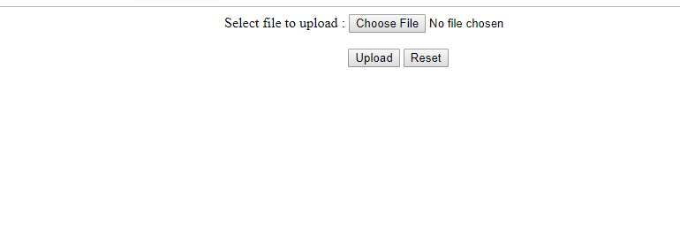

|  |  |
| --- | --- |
| **Step 1** | Open System **>** Attendance Information **>** File Upload & Process |
| **Step 2** | Choose File Type (Attendance/Roster) |
| **Step 3** | Click **Choose File** to choose the desired file |
| **Step 4** | Click **Upload** (file will be uploaded; check uploaded Attendance/Roster file) |
| **Step 5** | After Checking click **Confirm** button to Confirm the upload |
| **Result** | New Attendance File will be uploaded |



# [Attendance info Update](http://192.168.1.17:8090/zab/login?screen=opdoheader&option=Invoice+Entry&menuname=op)

After uploading attendance file Upadte the Attendance info (if required)

Header

|  |  |
| --- | --- |
| **Step 1** | Open System **>** Attendance Information **> Attendance info Update** |
| **Step 2** | Write Position ID and pick a Date |
| **Step 3** | Click **Show** |

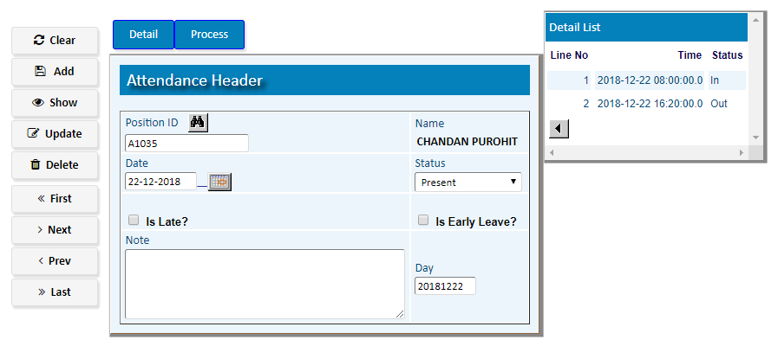

For Update OD/Late/Present Status --- Click **Detail**

|  |  |
| --- | --- |
| **Step 1** | Enter Date, Status (In, Out, OD). |
| **Step 2** | Write Hour, Minute & Second |
| **Step 3** | Click **Add** |
| **Step 4** | Follow the Steps 1 to 3 to add more Items. |

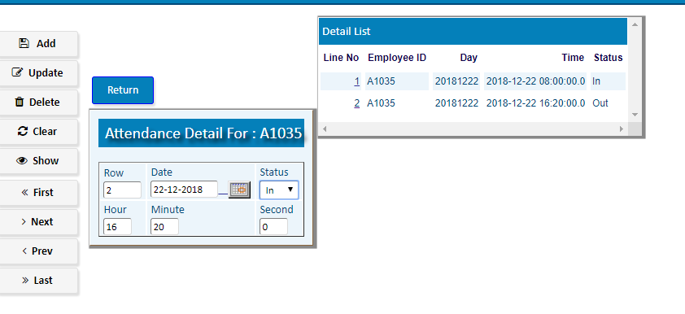

**) Click **Return** to return to Header

|  |  |
| --- | --- |
| **Step 5** | Click **Process** to confirm the update |
| **Result** | Attendance info will be Updated |

# [Attendance Process](http://192.168.1.17:8090/zab/login?screen=opdoheader&option=Invoice+Entry&menuname=op)

(To Confirm attendance info of Uploaded File execute **Attendance Process**)

|  |  |
| --- | --- |
| Step 1 | Open System **>** Attendance Information **> Attendance Process** |
| **Step 2** | Fix Processing Days (From Date, To date) |
| **Step 3** | Write Employee ID to process for a Single Staff (Processing For All, Keep this field Blank) |
| **Step 4** | Click **Process** |
| **Result** | **Attendance Process** will be Executed for the mentioned Days**.** |

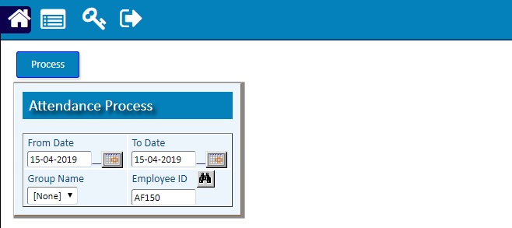

1. **Roster Entry**

(To assign Shift, Weekend for any Staff, go to **Roster Entry**)

|  |  |
| --- | --- |
| **Step 1** | Open System **>** Attendance Information **> Roster Entry** |
| **Step 2** | Fix Start Date, End Date of roster |
| **Step 3** | Enter Shift, Staff ID and then Assign Holiday (If Applicable) |
| **Step 4** | Click **Add** |
| **Result** | A new Roster for that Employee will be added within the Date Coverage |

To make sure at first Click **Trial Run** and then show report by Clicking **Print Trial Roster.**

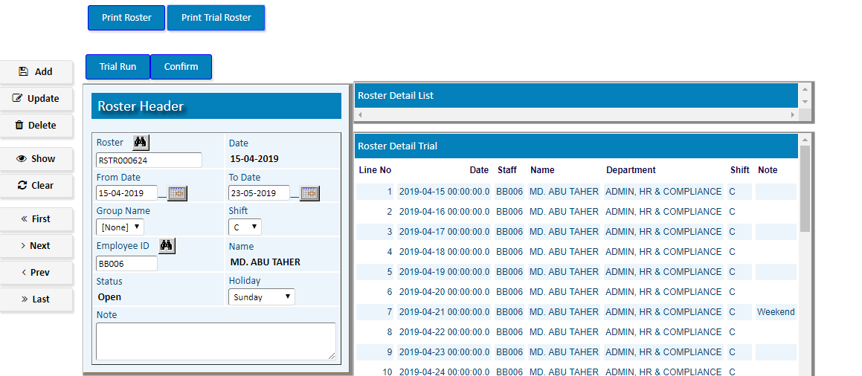

For Confirmation, Click **Confirm** and then show report by Clicking **Print Roster.**

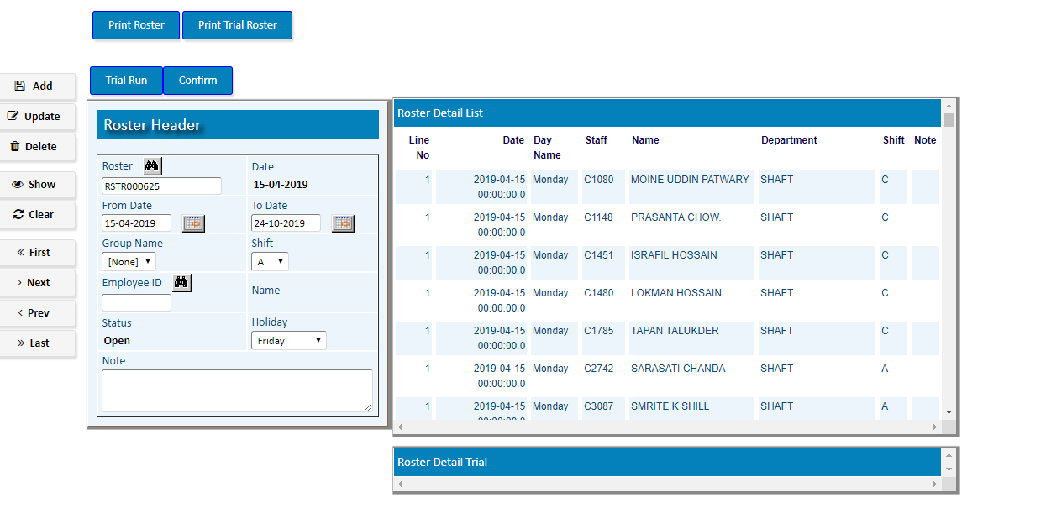

1. **Roster Entry Process**

(To change Shift (for Assigned Dates) of staffs assigned in Employee Master/ Roster Entry go to **Roster Entry process**)

|  |  |
| --- | --- |
| **Step 1** | Open System **>** Attendance Information **> Roster Entry Process** |

|  |  |
| --- | --- |
| **Step 2** | Fix Start Date, End Date of roster |

|  |  |
| --- | --- |
| **Step 2** | Select Existing Shift & Destination Shift |
| **Step 4** | Select Shift Source (Master/Roster) & Assign Holiday |
| **Step 6** | Click **Add** and then click **Process** |
| **Step 6** | To show the Process result click **Print Roster** |
| **Result** | A new Roster Process will be Executed. |

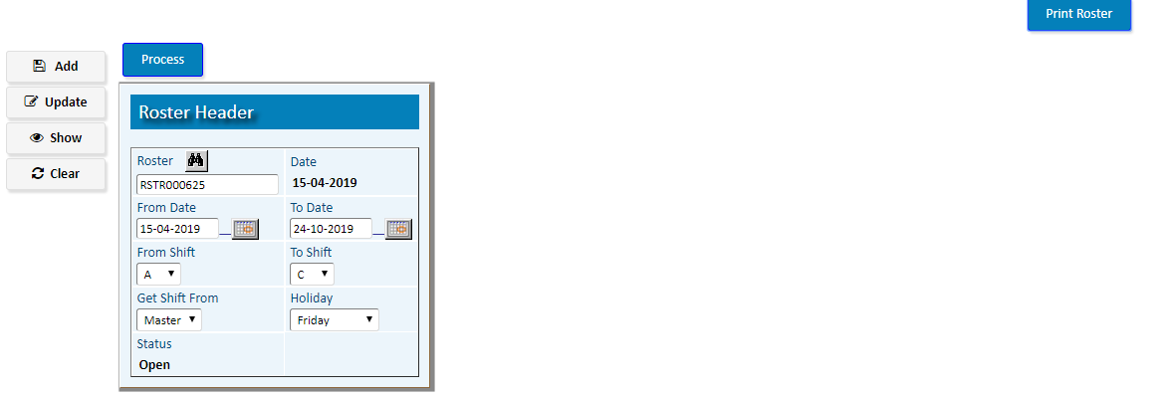

1. **Roster Update**

|  |  |
| --- | --- |
| **Step 1** | Open System **>** Attendance Information **> Roster Update** |
| **Step 2** | Pick a staff ID. |
| **Step 3** | Click **Show** |
| **Step 4** | Click **Detail** to update Roster day wise for that Staff |
| **Step 5** | Add/Update **Shift** /Weekend of required days for that Staff |

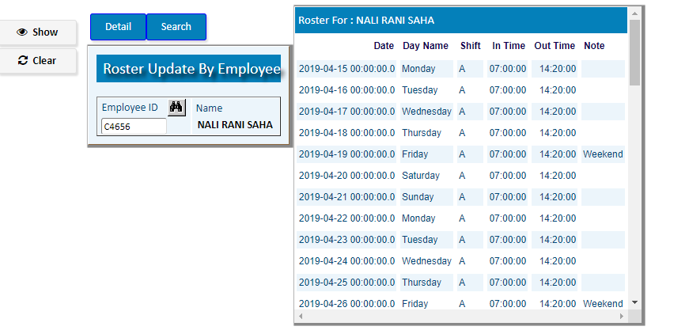

|  |  |
| --- | --- |
|  |  |
|  |  |
|  |  |

1. **Reports**

|  |  |
| --- | --- |
| **Step 1** | Open System **>** Attendance Information **> Reports** |
| **Step 2** | Select the Report option to show any Report |
| **Step 3** | Write the required Parameters and then Print Repot |

